Configuring MTA-STS Using Cloudflare Workers
NB!
Generic MTA-STS Policies have been created, which cover the below situations:
Office 365 + Proofpoint
Office 365 Only
Null MX
The correct default policy MUST be applied
- Sign into Cloudflare
- Click “Workers and Pages”
- Click the MTA-STS which applies to this situation
- Click “Settings”
- Under “Domains & Routes”
  - Click “+ Add”
  - Click “Custom Domain”
  - Type mta-sts.domain.com
  - Click “Add domain”
- Under Domains & Routes”
  - Click “+ Add”
  - Click Route
  - Select the Domain from the “Zone” Dropdown
  - Type “mta-sts.domain.com/.well-known/mta-sts.txt”
  - Click “Add route”
- Click “Websites” on the left-hand menu
- Search for the domain you’re currently working on
- Click the domain
- Click “DNS” on the left-hand menu
- For the first DNS Record:
  - Click “Add Record”
  - Set record type to “TXT”
  - Set name to _smtp._tls
  - Set content to v=TLSRPTv1; rua=mailto:smtptls@cloudboxtech.com
  - Click “Save”
- For 2nd DNS Record
  - Click “Add Record”
Set record type to “TXT”
  - Set name to _mta-sts
  - Set content to v=STSv1; id=YYYYMMDD
    - E.g. v=STSv1; id=20240416
  - Click “Save”
- Go to MTA-STS validator - Mailhardener tools
- Type in the name of the domain you were working on
- Click “Inspect”
- You should get the below output, bear in mind that delays in DNS propagation can cause this to fail.
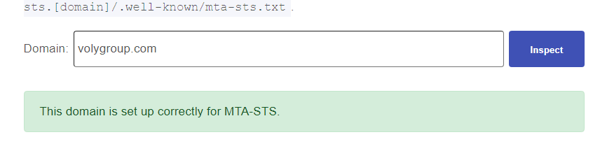
- If this fails, try again in about 30 mins
- If this still fails afterwards, troubleshooting can be done based on the outcome of this test.

